ELCT 201 – EE Laboratory 1

Lab 6 Report: Analog and digital electronics in systems of systems

Carson Murray

26 October 2022

Department of Electrical Engineering

University of South Carolina

Columbia, SC 29208

# Abstract

For this lab, a circuit to power a motor was constructed to include all the elements that were discussed and studied in prior labs. A set-reset flip flop (SR flip flop) implemented digital logic into the circuit, allowing the user to turn the motor on or off. A thermistor was included in this circuit as a simulated safety precaution, turning off the motor if the temperature crosses a threshold. Similarly, A current sensing shutoff was implemented to turn off the motor if it draws too much current. Lastly, a photoconductor allowed the user to start the motor by shining a light over it. Troubleshooting the circuit was especially important due to the many individual parts of the circuit. Various concepts such as digital logic, subsystems as well as sensors are discussed throughout this lab.

# Introduction

This project is guided by three main objectives, which are explored throughout the project. The first objective of this project is to be able to arrange functional components to create a system that can be used for a specific purpose. For example, the construction of a lowpass circuit is necessary in this circuit to reduce the amount of noise generated by the motor. It is important to know how to construct a lowpass filter because it could be used for many other circuits, depending on the design requirements.

Another objective of this project is for the student to understand that subsystems of a greater system can be built, tested, and debugged independently of the other subsystems. This is important because complex systems require a divide and conquer method of testing, as testing every subsystem at once would be extremely hard to trouble shoot and fix. This is important in this project because there are multiple different subsystems within the entirety of the circuit, and it was necessary to check each subsystem individually before testing the entire circuit.

The last objective was to develop troubleshooting skills and strategies to ensure the circuit is working properly. A troubleshooting diagram was constructed and utilized in this project to assist the process for checking individual subsystems. This follows very closely to the second objective as without troubleshooting strategies, it would be exceedingly difficult to make sure that each individual subsystem is working properly.

# Description of Circuit

The circuit constructed for this project is at the simplest level, a switch to power on a motor. This circuit contains many subsystems to function correctly such as: user inputs, sensor inputs, sensitivity calibrations, digital logic, and power output. The subsystems are shown in Figure 1:

Figure : Circuit diagram of the motor control system, composed of five subsystems- user input, sensor inputs, sensitivity calibration, logic, and power output.

## User inputs

User inputs for this circuit consist of two switches, connected to the digital logic subsystem. The switches serve as input for the flip flop, one switch “sets” the flip flop while the other switch “resets” the flip flop. When the circuit is completed, pressing the set button would start the motor and pressing the reset button would turn off the motor. LEDs are connected to each switch to show when a set or reset is being initiated.

## Sensor inputs

The light dependent resistor (LDR), thermistor, and a current sensing resistor are utilized as sensors to either set or reset the flipflop. The LDR sets the flip flop if it detects an increase in light. The thermistor resets the flip flops if it detects an increase of heat applied to it. Lastly, the motor current sensor will reset the flip flop if a force is applied to the motor to slow it down, thus drawing more current. It is important that the diodes connected to the LDR and thermistor output are connected correctly, as if they are placed backwards the sensor outputs will not reach the flip flop.

## Sensitivity calibration

Potentiometers were connected to their respective sensors to calibrate them to function how they are intended to. The potentiometers are adjusted so that they are slightly above the sensor’s voltage output when they are at rest. For example, the LDR’s potentiometer is set to about 2.5 Volts because the LDR outputs about 2 Volts at normal room lighting. Shining a flashlight over the LDR would lower its resistance, thus increasing its voltage past the threshold set by the potentiometer and setting the flip flop. The same general functionality is applied to the two other sensors, though they might have different threshold voltages. If the sensors are constantly setting/resetting the flip flop, or not setting/resetting the flip flop when they should then the potentiometer is not calibrated correctly.

## Digital Logic

The digital logic subsystem of this circuit creates a simple form of memory, allowing the output of this subsystem to stay active when set, and unactive when reset. Without this functionality, the motor would only stay on when a switch was actively setting it, therefore making the user hold down the set switch button or constantly shining a light on the LDR. The flip flop used in this circuit is a set-reset flip flop, thus it only takes set and reset as inputs. Connected to the set input are the outputs of the set switch and the LDR’s potentiometer. These inputs are fed through an OR gate created through a combination of NAND gates. The reset input is connected to the output of the reset switch, as well as the output of both the thermistor and current sensing resistor’s respective potentiometers.

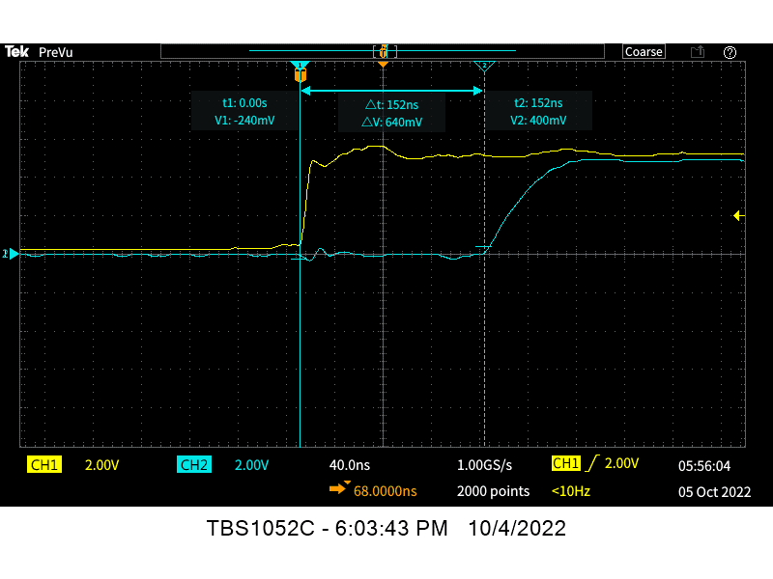

Figure : Oscilloscope screenshot of the delay in time from the moment when the “set” switch is activated to when the RS flip flop changes to logic high (set)

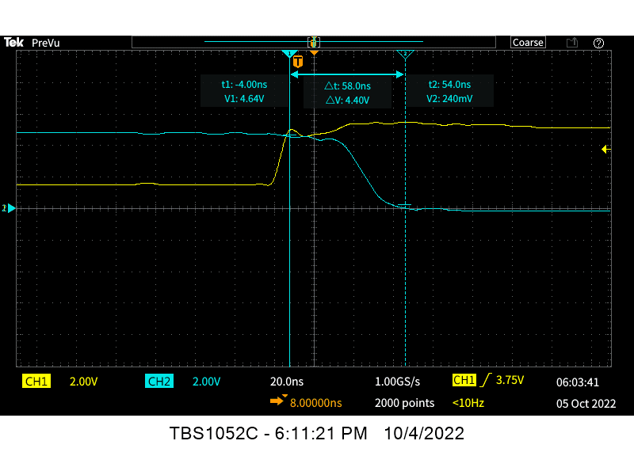

Figure : Oscilloscope screenshot of the delay in time from the moment when the “reset” switch is activated to when the RS flip flop changes ot logic low (reset)

Figures 2 and 3 illustrate the flip flop’s functionality as well as the slight time delay that occurs between when a switch is pressed, and the output is changed. This time delay occurs because of the logic gates that the signal must pass through to eventually output the desired signal.

## Power output

The power output subsystem allows the set output of the flip flop to power a motor. To achieve this, the output of the flip flop is connected to the base pin of the NPN transistor while its emitter is grounded and the collector is connected to the P-channel MOSFET. The MOSFET acts as the main power supply to the motor, as the 12V are supplied to it. A D-freewheel diode is connected to the output of the MOSFET to dissipate the current stored in the motor. The energy stored by the motor as well as the voltage across the motor are shown in Equations 1 and 2:

(Eq. 1)

(Eq, 2)

# troubleshooting

Due to the complexity of the circuit required for this project, there were many instances where troubleshooting was necessary to locate mistakes. Problems such as open circuitry, mis-calibrated potentiometers, diodes incorrectly inserted, and damaged components occurred throughout his project. To decrease the amount of time needed to find a problem in the circuit, a troubleshooting diagram was constructed and can be seen in Figure 4.

Figure : Troubleshooting diagram for motor control system.

To ensure that we could troubleshoot a problem that occurred to our circuit, our circuit was intentionally changed so that we would have to find the problem. The troubleshooting diagram was helpful as a guide, checking every subsystem individually.

First, only one component of the circuit was changed so that it would not operate correctly. When testing the circuit, it was apparent that the thermistor was not able to reset the motor after it had already been set. Following my diagram, I was able to find that the problem was that the diode connecting the output of the thermistor’s potentiometer to the flip flop was flipped.

Figure : Annotated troubleshooting diagram for one problem on motor control system.

Lastly, two parts of the circuit were changed so that it would be nonoperational. I first noticed that no input would turn on the motor. After checking my troubleshooting diagram, I realized that a connection must be wrong. After careful inspection, a wire had been disconnected from the NPN transistor. After reconnecting the wire to its correct position, the motor started moving again, but I was unable to reset it. This meant that the flip flop was being constantly set. The troubleshooting diagram indicated that it was a problem with the LDR. After checking the connection, I realized that the potentiometer must be uncalibrated. Once calibrated, the circuit was working successfully again.

Figure : Annotated troubleshooting diagram of motor control system with 2 problems.

# Conclusions

The combination of user input, sensor input, sensitivity calibration, digital logic, and power output subsystems create a functional motor control circuit. Each individual subsystem provides extra challenges to fixing problems that arise in the circuit. I can conclude that troubleshooting diagrams are helpful in reducing the time needed to find the solution to a problem. Also, breaking down the circuit into its smaller subsystems creates an easier process for finding and fixing any issue that may occur.